PS Resin (chimei)

This solid polymer is formed by heat polymerization of styrene monomer. This product is referred to as the general purpose polystyrene, also known as hard plastic. Generally speaking,  general purpose polystyrene has the advantages of being bright, lightweight, transparent, low cost, etc. In addition, if rubber is added and mixed during the polystyrene production process, impact resistant and non-transparent polystyrene commonly known as the high impact polystyrene (HIPS) can be developed.

[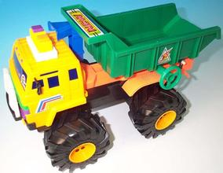](http://image.baidu.com/i?ct=503316480&z=&tn=baiduimagedetail&ipn=d&word=%E5%A1%91%E8%83%B6%E7%8E%A9%E5%85%B7&step_word=&ie=utf-8&in=1380&cl=2&lm=-1&st=-1&pn=1&rn=1&di=38466868330&ln=2000&fr=&&fmq=1392360019292_R&ic=0&s=&se=1&sme=0&tab=&width=&height=&face=0&is=&istype=2&ist=&jit=&objurl=http%3A%2F%2Fwww.buildweb.com.cn%2Fuser%2Fwanju%2Fmedia%2Fimage%2F36304.jpg)[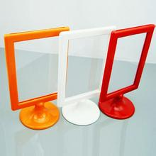](http://image.baidu.com/i?ct=503316480&z=&tn=baiduimagedetail&ipn=d&word=%E5%A1%91%E8%83%B6%E7%9B%B8%E6%9E%B6&step_word=&ie=utf-8&in=19613&cl=2&lm=-1&st=-1&pn=50&rn=1&di=90256174800&ln=1999&fr=&&fmq=1392360296206_R&ic=0&s=&se=1&sme=0&tab=&width=&height=&face=0&is=&istype=2&ist=&jit=&objurl=http%3A%2F%2Fcn.gcimg.net%2Fgcproduct%2Fday_20130124%2F48412492d4cf176b3bd9c68e4c06667a.jpg)